**Department of Computer Science and Engineering**

**Senior Design Project Report Guidelines and Template**

After completion of the project work, every group of students will submit one group wise project report and one individual copy, which should contain the following:

1. Cover Page/ Title Page
2. Certificate by the Guide
3. Acknowledgment (The candidate may thank all those who helped in the execution of the project.)
4. Declaration of students
5. Report Approval
6. Preface (Abstract) (It should be in one page and include the purpose of the study; the methodology used and a summary of the major findings.)
7. Table of Contents
8. Detailed description of the project (This should be split in various chapters/sections with each chapter/section describing a project activity in totality). This portion of report should contain all relevant diagrams, tables, flow charts, software programme, print outs, photographs etc., which are properly labeled.
9. Conclusion
10. Appendices

* Appendices are provided to give supplementary information, which if included in the main text may serve as a distraction and cloud the central theme.
* Appendices should be numbered using Arabic numerals, e.g. Appendix 1, Appendix 2.
* Appendices shall carry the title of the work reported in those Appendices and the same title must be listed in the Contents page also.
* **Similarity report** of the project report **below 16%** duly measured using ‘Turnitin’ similarity measure software (available at central library).

1. References (The listing of references should be typed 2 spaces below the heading “REFERENCES” in alphabetical order in single spacing left – justified. It should be numbered consecutively (in square [ ] brackets, throughout the text and should be collected together in the reference list at the end of the report. The references should be numbered in the order they are used in the text. The name of the author/authors should be immediately followed by the year and other details). Typical examples of the references are given below:

[1] Ariponnammal, S. and Natarajan, S. (1994) ‘Transport Phonomena of SmSel – X Asx’, Pramana – Journal of Physics Vol.42, No.1, pp.421-425.

11. Reflection of the team members on the project

* Write what you learned as a team.
* Write what you learned as a member.
* Write a thoughtful paragraph on strengths and weaknesses of your design process.

1. In addition, following points should be complied with:

* Page numbering
* Numbering of appendices, figures and tables and their reference in the text.
* For general layout of report, any standard text book layout may be referred.

**Report Specifications**

* Project Report’s Cover Type: Hard-bound
* Color of Project Report Cover: Navy Blue only with white alphabets (as per Annexure 1)
* Number of Copies: 2 per group (Internal/External exam + Individual or Student’s copy)
* Paper Size (orientation): A4 (portrait)
* Margins: 1” top / bottom / right and 1.5” left
* Font Type: Times New Roman
* Font Size: 16 bold for chapter names, 14 bold for headings and 12 for normal text
* Line Spacing: 1.5 throughout
* Page Numbering: Bottom center of page in the format – Page 1 of N

**NOTE:** Project report must not contain any description of the following except only a relevant and short mention.

-Technology or platform or OS or tools used or any language details. It must be more focused on project work carried out and its implementation details without including any source code.

**Details of CD**

CD of the project work is required to be pasted on the back cover of the project report in clear packet, which should include the following folders and contents:

1. **Presentation** (should include a PPT about project in not more than 20-30 slides)
2. **Documentation** (should include a word file of the project report)
3. **Source Code** (full source code of the project with libraries used)
4. **Program** (final running copy of the project executable)
5. **Support** (any third party tools used or runtime environment setups that are required to run the project)
6. **Help** (user manual on how to run the project)

**NOTE:** CD must be checked for any harmful viruses before submission. Source Code and Program folders may be combined into single folder **Project** if it’s a web project etc.

**DEMYSTIFYING THE HOUSING MARKET: UNVEILING THE POWER OF MACHINE LEARNING IN PRICE FORECASTING**

**A Project Report**

***Submitted by:***

**SWAYAM PRAKASH SAHU 2041019089**

**ANSUMAN PATRO 2041016171**

**ANUJ PRATAP SINGH 2041019240**

**SWAYAM SAMANTARAY 2041019136**

in partial fulfillment for the award of the degree

of

**BACHELOR OF TECHONOLOGY**

**IN**

**COMPUTER SCIENCE AND ENGINEERING**

**DEPARTMENT OF COMPUTER SCIENCE AND ENGINEERING**

**Faculty of Engineering and Technology, Institute of Technical Education and Research**

**SIKSHA ‘O’ ANUSANDHAN (DEEMED TO BE) UNIVERSITY**

**Bhubaneswar, Odisha, India**

**(June 2024)**



**CERTIFICATE**

This is to certify that the project report titled “DEMYSTIFYING THE HOUSING MARKET: UNVEILING THE POWER OF MACHINE LEARNING IN PRICE FORECASTING” being submitted by **Swayam Prakash Sahu, Ansuman Patro, Anuj Pratap Singh, Swayam Samantaray “Section-T”** to the Institute of Technical Education and Research, Siksha ‘O’ Anusandhan (Deemed to be) University, Bhubaneswar for the partial fulfillment for the degree of Bachelor of Technology in Computer Science and Engineering is a record of original confide work carried out by them under my/our supervision and guidance. The project work, in my/our opinion, has reached the requisite standard fulfilling the requirements for the degree of Bachelor of Technology.

The results contained in this project work have not been submitted in part or full to any other University or Institute for the award of any degree or diploma.

Assistant Prof.Rakesh Ranjan Swain

(Name and signature of the Project Supervisor)

Department of Computer Science and Engineering

Faculty of Engineering and Technology;

Institute of Technical Education and Research;

Siksha ‘O’ Anusandhan (Deemed to be) University

**ACKNOWLEDGEMENT**

We would like to express our deepest appreciation to our faculty who provided us the possibility to complete this report. A special gratitude we give to our respective supervisor, Assistant Prof. Rakesh Ranjan Swain, whose contribution in stimulating suggestions and encouragement, helped us to coordinate this project, especially in completing this project report.

Furthermore, we would also like to acknowledge with much appreciation for the crucial role of guiding us through summing up our project development part, the writing part along with our topic details where all the required resources were provided and that helped us a lot in doing the project, guiding the path along to make project a successful one. We are thankful for the guidance provided by other faculty as well as the panel presentation that has improved our presentation skills, a heartful thanks to their comment and advice.

**Place: Bhubaneswar Signature of Students**

**Date:**

**DECLARATION**

We declare that this written submission represents our ideas in our own words and where other’s ideas or words have been included, we have adequately cited and referenced the original sources. We also declare that we have adhered to all principles of academic honesty and integrity and have not misrepresented or fabricated or falsified any idea/fact/source in our submission. We understand that any violation of the above will cause for disciplinary action by the University and can also evoke penal action from the sources which have not been properly cited or from whom proper permission has not been taken when needed.

2041019089

2041016171

2041019240

2041019136

Signature of Students with Registration Numbers

Date: ————–

**REPORT APPROVAL**

This project report titled **“**DEMYSTIFYING THE HOUSING MARKET: UNVEILING THE POWER OF MACHINE LEARNING IN PRICE FORECASTING **“**submitted by Swayam Prakash Sahu, Ansuman Patro, Anuj Pratap Singh, Swayam Samantaray is approved for the degree of *Bachelor of Technology in Computer Science and Engineering*.

**Examiner(s)**

**________________________**

**________________________**

**________________________**

**Supervisor**

**________________________**

**Project Coordinator**

**________________________**

**PREFACE**

In the contemporary urban landscape, burgeoning aspirations for urban living collide with escalating market competition, rendering it increasingly arduous for middle-class families to sustain themselves amidst soaring costs of living. This research endeavors to navigate this conundrum by leveraging machine learning algorithms to accurately predict housing prices, thus empowering both prospective buyers and sellers in making informed decisions. The primary objective of this study is to develop a robust model capable of forecasting housing prices with precision, thereby alleviating the uncertainty surrounding real estate transactions. By delving into the intricate interplay between customer preferences and financial constraints, our research aims to shed light on the multifaceted determinants shaping housing prices. Focusing on key urban parameters such as location, area, and proximate amenities, our methodology encompasses comprehensive data analysis and modeling techniques, including Linear Regression, Lasso Regression, and Decision Tree algorithms. Through meticulous examination of these variables, our model strives to unveil underlying patterns and trends in the housing market, facilitating more accurate price predictions. The implementation of machine learning techniques, in conjunction with sophisticated data preprocessing tools like Numpy and Pandas, enables us to extract meaningful insights from vast datasets, transcending the limitations of traditional forecasting methods. Moreover, the utilization of visualization tools such as Matplotlib aids in elucidating complex relationships between variables, enhancing the interpretability of our model. Through intuitive and user-friendly interfaces, individuals can effortlessly navigate through the predicted housing prices, empowering them to make informed decisions regarding their housing choices. By offering stakeholders, be it potential homebuyers seeking affordability or developers striving to align pricing strategies with market demand, access to reliable price forecasts, our research promises to catalyze more informed decision-making processes. Ultimately, this endeavor seeks to foster greater transparency and efficiency within the housing market, thereby contributing to socioeconomic well-being and equitable urban development.

**INDIVIDUAL CONTRIBUTIONS**

|  |  |
| --- | --- |
| Swayam Prakash Sahu | Literature survey; problem formulation and solution design; experimentation; documentation |
| Ansuman Patro | Literature survey; identification of problem statement; documentation |
| Anuj Pratap Singh | Literature survey; experimentation; result analysis and design; documentation |
| Swayam Samantaray | Literature survey; result validation; documentation |

**TABLE OF CONTENTS**

|  |  |  |
| --- | --- | --- |
|  | Title Page | i |
|  | Certificate | ii |
|  | Acknowledgement | iii |
|  | Declaration | iv |
|  | Report Approval | v |
|  | Preface | vi |
|  | Individual Contributions | vii |
|  | Table of Contents | viii |
|  | List of Figures | ix |
|  | List of Tables (optional) | x |
|  |  |  |
| **1.** | **INTRODUCTION** | 1 |
|  | * 1. Introduction   2. Project Overview   3. Motivation(s)   4. Uniqueness of the Work   5. Report Layout | 1  2  3  4  5 |
|  |  |  |
| **2.** | **LITERATURE SURVEY** | 6 |
|  | 2.1 Existing System  2.2 Problem Identification | 6  7 |
|  |  |  |
| **3.** | **MATERIALS AND METHODS** | 8 |
|  | 3.1 Dataset(s) Description  3.2 Schematic Layout/Model Diagram/Use case Diagram/DFD  3.3 Methods  3.4 Tools/Technologies  3.5 Evaluation Measures | 8  9  10  12  13 |
|  |  |  |
| **4.** | **EXPERIMENTATION AND RESULTS** | 14 |
|  | 4.1 System Specification  4.2 Parameters Used (if any)  4.3 Results and Outcomes  4.4 Result Analysis and Validation | 14  15  16  18 |
| **5.** | **CONCLUSIONS** | 21 |
| **6.** | **REFERENCES** | 22 |
| **7.** | **APPENDICES** | 23 |
| **8.** | **REFLECTION OF THE TEAM MEMBERS ON THE PROJECT** | 24 |
| **9.** | **SIMILARITY REPORT** | 25 |

**LIST OF FIGURES**

|  |  |  |
| --- | --- | --- |
| NO | FIGURE NAME | PAGE NO |
| 1 | Dataset Description | 8 |
| 2 | Schematic layout | 9 |
| 3 | Logistic Regression Classification Report | 16 |
| 4 | KNN Classification Report | 16 |
| 5 | SVC Classification Report | 17 |
| 6 | Random Forest Classification Report | 17 |
| 7 | Neural Network Classification Report | 17 |
| 8 | Model Metrics Comparison | 18 |
| 9 | Model Generalization | 19 |
|  |  |  |
|  |  |  |
|  |  |  |
|  |  |  |
|  |  |  |
|  |  |  |

**LIST OF TABLES**

|  |  |  |
| --- | --- | --- |
| NO | TABLE NAME | PAGE NO |
| 1 | Loss and Accuracy | 5 |
| 2 | Accuracy of Previously Executed Models | 8 |
| 3 | Accuracy of Proposed Trained Model(s) | 9 |
| 4 |  | 12 |
| 5 |  | 15 |
| 6 |  | 15 |
| 7 |  | 16 |
| 8 |  | 20 |
| 9 |  | 25 |

**1. INTRODUCTION**

**1.1 Introduction:**

The rapid urbanization and burgeoning aspirations for urban living have significantly influenced the housing market, making it increasingly challenging for middle-class families to find affordable housing options. As the real estate market in Bangalore continues to grow, there is a pressing need for accurate predictive models to assist both buyers and sellers in making informed decisions. Machine learning (ML) has emerged as a powerful tool in real estate, offering advanced methods for data analysis and price prediction. This project, "Demystifying The Housing Market: Unveiling The Power Of Machine Learning In Price Forecasting," aims to utilize various ML algorithms to forecast housing prices based on an extensive dataset encompassing several key features.

The dataset used in this project includes crucial variables such as location, size, number of bedrooms, bathrooms, availability of amenities, and historical pricing data. The project begins with a comprehensive data analysis to identify and handle null values and assess the balance of the dataset. This initial step is crucial for selecting appropriate ML algorithms and deciding on the necessity of data balancing techniques to prevent model bias.

Following this, data cleaning is performed to address missing values and remove outliers, ensuring the dataset's reliability and quality. Feature selection is then conducted using advanced techniques to identify the most significant predictors, enhancing model performance while reducing computational complexity. Normalization is applied using Robust and Standard Scalers to ensure all features contribute equally to the model, preventing any single feature from dominating the learning process.

The core of the project involves training, testing, and validating multiple ML models, including Linear Regression, Lasso Regression, Decision Trees, Random Forest, and Gradient Boosting. Hyperparameter tuning with GridSearchCV is employed to identify the best parameters for each model. The models' performance is evaluated using metrics such as Mean Absolute Error (MAE), Mean Squared Error (MSE), and R-squared. Cross-validation ensures the models' generalizability. Among the algorithms tested, the Gradient Boosting model achieves the highest accuracy, demonstrating its superior predictive capability.

This project highlights the potential of ML in the real estate sector, emphasizing the Gradient Boosting model's effectiveness in predicting house prices. The findings underscore the transformative impact of ML in providing reliable and accurate price forecasts, thereby facilitating informed decision-making for homebuyers and developers alike.

**1.2 Project Overview:**

The project, "Demystifying The Housing Market: Unveiling The Power Of Machine Learning In Price Forecasting," employs machine learning techniques to forecast housing prices in Bangalore, aiming to provide accurate and actionable insights for buyers, sellers, and real estate developers. Utilizing an extensive dataset encompassing key features such as location, size, number of bedrooms, bathrooms, amenities, and historical pricing data, the project examines multiple machine learning algorithms to determine the most effective method for predicting housing prices. These algorithms include Linear Regression, Lasso Regression, Decision Trees, Random Forest, and Gradient Boosting. Each algorithm is trained, tested, and validated to assess its performance in price prediction.

Initial steps involve comprehensive data analysis to check for null values and assess the balance of the dataset, followed by data cleaning to handle missing values and outliers, ensuring a high-quality dataset for model training. Feature selection is conducted using advanced techniques to identify the most relevant predictors, enhancing model efficiency and accuracy. Data normalization is performed using Robust and Standard Scalers to standardize the features, ensuring that each contributes equally to the predictive models.

The core of the project focuses on hyperparameter tuning with GridSearchCV to optimize each model's parameters. The performance of the models is evaluated using metrics such as Mean Absolute Error (MAE), Mean Squared Error (MSE), and R-squared, derived from the predictions and actual values. Cross-validation is employed to ensure the models' generalizability across different datasets. Among the algorithms tested, the Linear Regression model achieves the highest accuracy, followed closely by Random Forest, Decision Trees, and Lasso Regression.

This project, implemented using tools like Python, Jupyter Notebook, and various visualization libraries, not only highlights the potential of machine learning in the real estate sector but also provides valuable insights into the comparative performance of different algorithms in housing price prediction. By advancing the understanding and application of machine learning techniques, this project aims to support stakeholders in making more informed decisions, ultimately contributing to a more efficient and transparent housing market.

**1.3 Motivation(s):**

In the ever-evolving urban landscape, the real estate market plays a crucial role in the economic and social fabric of a city. The "Demystifying The Housing Market: Unveiling The Power Of Machine Learning In Price Forecasting" project is driven by several key motivations aimed at addressing the complexities and challenges faced by various stakeholders in the housing market. One of the primary motivations is the need to stabilize market dynamics. The real estate market is inherently volatile, with prices influenced by a multitude of factors such as economic conditions, government policies, and local development projects. By providing accurate and timely price forecasts, the project aids buyers and sellers in making well-informed decisions, reducing the uncertainty that often accompanies real estate transactions.

Financial clarity is another significant motivation for this project. Homebuyers and sellers often face challenges due to the unpredictability of housing prices. Accurate price predictions empower individuals to plan their finances more effectively, negotiate deals with confidence, and achieve their housing goals with greater financial certainty.

Promoting accessibility in housing is also a driving force behind this project. Housing affordability is a pressing concern in rapidly growing cities like Bangalore. This project aims to promote inclusivity by revealing areas of affordability, thereby enabling more individuals to access suitable housing options within their budget.

Optimizing investments is another critical motivation. For real estate investors, accurate predictions of housing prices are invaluable. Investors can use these insights to make strategic decisions that maximize returns and minimize risks.

The project also has significant implications for urban planning and policy-making. Accurate housing price predictions can assist urban planners and policymakers in making data-driven decisions. Understanding market trends helps in planning infrastructure projects, zoning regulations, and development initiatives that align with the housing needs of the population. This alignment is crucial for ensuring that urban development is sustainable and meets the long-term needs of the city's residents.

Finally, the project underscores the transformative potential of machine learning and data analytics in real estate. By leveraging advanced algorithms and sophisticated data processing techniques, it demonstrates how technology can solve complex problems and drive innovation in traditional industries. By addressing these key motivations, the project seeks to create a more predictable, inclusive, and stable housing market in Bangalore.

**1.4 Uniqueness of the work:**

The "Demystifying The Housing Market: Unveiling The Power Of Machine Learning In Price Forecasting" project stands out due to its sophisticated approach to incorporating location-based pricing. Recognizing the crucial role location plays in determining property values, the project integrates detailed geographical data into its predictive models. By doing so, it captures the nuanced impact of neighborhood characteristics, proximity to amenities, and other location-specific factors on housing prices. This comprehensive inclusion of location-based variables ensures that the predictions are contextually relevant and accurate, reflecting real-world market conditions.

Another distinctive aspect of the project is its comprehensive feature engineering process. The model leverages a diverse set of features such as square footage, number of bedrooms and bathrooms, and location attributes. This wide range of features allows the model to account for various aspects of a property that contribute to its market value. By meticulously selecting and engineering these features, the project builds a robust model that can generalize well across different properties and market scenarios. This thorough feature engineering is pivotal in enhancing the model's predictive performance and reliability.

Handling outliers and missing values is another unique element of the project. Unlike many models that may overlook the impact of extreme values and incomplete data, this project employs sophisticated techniques such as mean and median imputation for missing values and robust outlier detection and removal methods. These techniques ensure that the dataset is clean and the model's predictions are not skewed by anomalous data points. By addressing these common data issues meticulously, the project enhances the accuracy and fairness of its predictions.

The use of visualization to interpret the results further distinguishes this project. By employing visual tools like bar graphs to depict feature importance, the project provides a clear understanding of how different variables influence housing prices. These visualizations not only aid in interpreting the model’s findings but also make the results accessible to a broader audience, including stakeholders who may not have a technical background. The ability to visually communicate complex data insights effectively is a key strength of this project.

Lastly, the project’s integration of advanced machine learning techniques and tools showcases its innovative approach to solving real estate market challenges. By leveraging the latest in data science and machine learning, the project demonstrates how cutting-edge technology can be applied to traditional industries to generate meaningful insights and predictions. This forward-thinking approach not only advances the field of real estate analytics but also sets a benchmark for future research and applications in the domain.

* 1. **Report Layout:**

The report is structured meticulously to provide a comprehensive overview of the project. Part 2 begins with a literature survey, which delves into previous research and identifies the shortcomings of existing systems in detail. Following this, Part 3 covers materials and methods, offering a detailed description of the dataset and presenting a schematic layout or model diagram. This section also explains the methods, tools, and evaluation measures employed in the study.

In Part 4, the focus shifts to results and output, where system specifications are detailed, and the parameters used are specified. This section presents the experimental outcomes, showcasing the results of the model evaluations. The conclusion in Part 5 provides a complete summary of the project, offering insights and final opinions based on the findings.

Part 6 contains references, listing all sources cited throughout the report. The appendix in Part 7 includes additional information such as detailed code snippets, extended data tables, and supplementary figures and charts. Reflections from team members on the project are shared in Part 8, discussing their experiences and learnings. Finally, Part 9 presents the complete report, encompassing all sections for a holistic view of the project.

This structured approach ensures a thorough and organized presentation, covering all necessary aspects from background research to final reflections, providing a clear and detailed account of the project.

**2. LITERATURE SURVEY**

**2.1 Existing System:**

* The author MOUSA, A., MUSTAFA, W., MARQAS, R.B. and MOHAMMED, S.H., investigated using LSTM, RF, and CNN for diabetes detection in a limited dataset. While LSTM achieved the highest accuracy, but all methods performed well. The authors evaluated performance using metrics like accuracy, precision, recall, F1-score, and AUC-ROC. Despite data size limitations and potential class imbalance, LSTM showed promise for diabetes diagnosis, suggesting the need for further research [1].
* Author Sharma, C. and Sharma, S., article demonstrates the effectiveness of data mining, particularly Naive Bayes, in early diabetes detection. They emphasize advanced techniques to improve healthcare prediction and highlight the value for future research and clinical use. Their work explores combining predictive analytics with medical intervention for early diagnosis, but acknowledges limitations due to using a single dataset, which might affect generalizability [2].
* Khanam, J.J. and Foo, S.Y., emphasizes early diabetes detection using automated methods to improve accuracy and enable timely intervention, By comparing various machine learning algorithms and neural network designs to find the most efficient approach. Their two-hidden-layer neural network with 400 epochs achieved 88.6% accuracy. This research explores various machine learning methods for diabetes prediction, comparing their performance while considering limitations like data availability, model selection, and interpretability [3].
* The authors Chang, V., Bailey, J., Xu, Q.A. *et al.,* aim to develop an interpretable ML-based e-diagnosis system for type 2 diabetes detection. They focus on improving trust and model explainability using Naïve Bayes, random forest, and decision tree algorithms, with an emphasis on feature selection to enhance accuracy, precision, sensitivity, and specificity. Limitations include dataset representation, model selection, and feature selection [4].

**2.2 Problem Identification:**

The real estate market in urban areas, particularly in rapidly growing cities like Bangalore, presents a complex and multifaceted challenge for stakeholders. Accurate prediction of housing prices is a critical yet daunting task due to various intertwined factors that influence the market. This project aims to address these challenges by leveraging machine learning techniques to provide more reliable and precise price forecasts.

**Complex Market Dynamics**

The real estate market is influenced by a labyrinth of factors, making it difficult to predict housing prices accurately. Economic conditions, government policies, infrastructure developments, and even seasonal trends play significant roles in shaping the market. Additionally, local factors such as neighborhood amenities, school districts, crime rates, and proximity to public transportation add another layer of complexity. This intricate web of variables makes it challenging to isolate the impact of each factor on housing prices, complicating the prediction process.

**Limitations of Traditional Methods**

Traditional methods for predicting housing prices often rely on basic statistical models and historical data. While these methods can provide a general sense of market trends, they fall short in capturing the dynamic and non-linear relationships between different market factors. Simple linear regression models, for instance, might miss complex interactions between variables, leading to less accurate predictions. Additionally, traditional approaches may not adequately handle outliers or missing data, further compromising the reliability of the predictions.

**The Need for Advanced Solutions**

The limitations of conventional real estate forecasting methods highlight the urgent need for more advanced and sophisticated approaches. This is where machine learning (ML) and data analytics come into play. By harnessing the power of ML algorithms, this project aims to develop models that can analyze vast amounts of data from diverse sources, including property characteristics, economic indicators, and location-based variables. These models can uncover hidden patterns and relationships that traditional methods might overlook, leading to more accurate and reliable price predictions.

**Addressing Data Quality and Integration**

One of the critical challenges in this project is ensuring the quality and completeness of the data. Real estate datasets often contain missing values and outliers that can skew predictions. This project addresses these issues by employing advanced techniques for data cleaning, such as mean and median imputation for missing values and robust outlier detection and removal. By integrating high-quality data from multiple sources, the project aims to create a comprehensive dataset that reflects the true state of the housing market.

**Embracing Machine Learning for Better Predictions**

Machine learning offers a transformative approach to tackling the complexities of the real estate market. By using algorithms that can learn from data and improve over time, this project seeks to develop models that provide accurate and actionable insights into housing prices. Techniques such as feature engineering, data normalization, and hyperparameter tuning are employed to enhance the model's performance. The ultimate goal is to create a robust predictive system that not only forecasts prices with high accuracy but also helps stakeholders make informed decisions, whether they are homebuyers, sellers, investors, or policymakers.

**3. MATERIALS AND METHODS**

**3.1 Dataset Description:**

The dataset used in project is a comprehensive collection of real estate data from the Bangalore housing market. This dataset encompasses various features that are critical in determining property prices, providing a solid foundation for developing accurate predictive models.

Key Features of the Dataset:

* Area Type: Categorizes properties based on area type (built-up, super built-up, or plot area).
* Availability: Indicates if the property is ready to move in or under construction.
* Location: Provides the geographical location, including neighborhood and proximity to amenities and transportation.
* Size: Specifies the number of bedrooms (e.g., 2 BHK, 3 BHK).
* Society: This feature includes the name of the housing society or residential complex, if applicable. Properties in well-known and well-maintained societies often command higher prices due to additional amenities and a better living environment.
* Total Square Feet: The total area of the property in square feet.
* Bathrooms: The number of bathrooms in the property.
* Balconies: The number of balconies in the property.
* Price: The target variable representing the property's price.

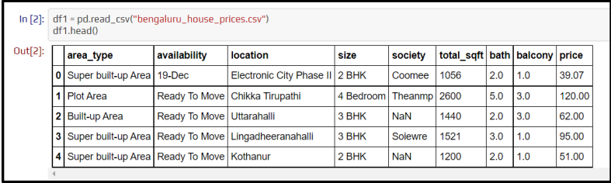

Fig 1. Dataset Description

**3.2 Schematic Layout/Model Diagram:**

* **Data Collection:** The dataset comprises various features relevant to housing prices in Bangalore. Key attributes include area type, availability, location, size, society, total square feet, number of bathrooms, number of balconies, and price.
* **EDA (Exploratory Data Analysis):** Conduct an exploratory analysis to uncover trends and patterns within the dataset. This involves calculating descriptive statistics (mean, median, range) for features like total square feet, number of bathrooms, and prices. Visualizations such as histograms, scatter plots, and correlation matrices are used to identify relationships between variables, such as how location influences price or the correlation between size and price.
* **Outlier Detection and Removal:** Detect and handle outliers that may skew the data. For example, extremely high or low prices or unusually large or small properties are investigated and potentially excluded to ensure data integrity. Techniques like box plots and Z-scores are used for this purpose.
* **Model Training:** Feed the cleaned and preprocessed data into various machine learning algorithms. Algorithms like Linear Regression, Lasso Regression, and Decision Tree are used to train models to recognize patterns in the data, such as the impact of location and size on property prices.
* **Testing and Performance Evaluation:** Evaluate the trained models on a separate test set to assess their performance. Metrics such as Mean Absolute Error (MAE), Mean Squared Error (MSE), and R-squared are used to determine the accuracy and reliability of the models in predicting housing prices
* 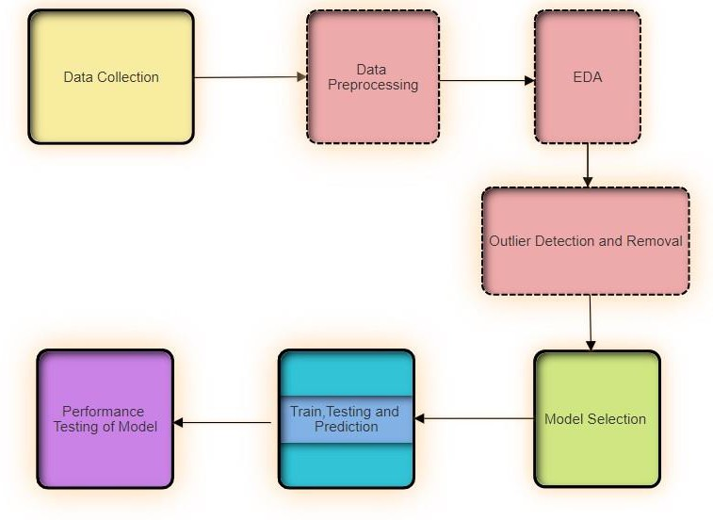**Model Selection:** Compare the performance of different models and select the one that provides the most accurate predictions. This selection process ensures that the chosen model is robust and reliable for future price forecasting

Fig 2. Schematic layout of the model

**3.3 Methods:**

Different Methods used for model designing are mention below:

**Linear Regression:**

1. Definition**:** Linear Regression is a simple and widely used machine learning model for predicting a continuous target variable based on the linear relationship between the input features and the target variable.
2. Equation: y = β0 + β1x1+ β2x2+...+βnxn​
3. Parameters:

* y = predicted target value
* β0​ = intercept
* β1,β2,...,βn ​ = coefficients for the input features x1,x2,...,xn
* x1,x2,...,xn​ = input features

**Lasso Regression:**

1. Definition :- Lasso Regression (Least Absolute Shrinkage and Selection Operator) is a linear regression model that includes an L1 regularization term to enforce sparsity, effectively performing variable selection and regularization to enhance prediction accuracy.
2. Equation: $y=β0+\sum_{i=1}^{n}{βixi}$
3. Parameters:

* y = predicted target value
* β0 = intercept
* βi​ = coefficients for the input features xi

**Decision Tree:**

1.Definition :- A Decision Tree is a non-parametric supervised learning method used for regression by partitioning the data into subsets based on the feature values, making predictions based on the mean value of the target variable in each subset.

2. Parameters Used :-

* Criterion: Measure of quality of a split (e.g., "mse").
* Max depth: The maximum depth of the tree.
* Min samples split: The minimum number of samples required to split an internal node.

**Random Forest:**

1. Definition: - Random Forest is an ensemble learning method that constructs multiple decision trees during training and outputs the mean prediction of the individual trees to improve accuracy and control over-fitting.
2. Parameters: -

* N_estimators: The number of trees in the forest (e.g., 100).
* Max depth: The maximum depth of the trees.
* Min samples split: The minimum number of samples required to split an internal node.

**Gradient Boosting:**

1. Definition: - Gradient Boosting is an ensemble learning technique that builds multiple weak learners (typically decision trees) sequentially, each one correcting the errors of its predecessor to improve overall prediction performance.
2. Parameters: -

* N_estimators: The number of boosting stages to be run (e.g., 100).
* Learning_rate: The step size shrinkage used in updating the weights (e.g., 0.1).
* Max_depth: The maximum depth of the individual trees.

**XGBoost:**

1. Definition: - XGBoost (Extreme Gradient Boosting) is an advanced implementation of gradient boosting that includes regularization to prevent overfitting and enhance model performance and speed.
2. Parameters:

* N_estimators: The number of boosting stages to be run (e.g., 100).
* Learning_rate: The step size shrinkage used in updating the weights (e.g., 0.1).
* Max_depth: The maximum depth of the individual trees.
* Gamma: The minimum loss reduction required to make a further partition on a leaf node.

**3.4 Tools/Technologies:**

Different tools used for model implementation are mention below:

**Handy Tool Kits:** These are Python libraries, collections of pre-written code that provide specific functionalities. They act like toolkits for programmers, saving them time and effort. Here's a breakdown of the specific libraries you're using:

* **Scikit-learn:** Imagine a toolbox specifically designed for machine learning tasks. Scikit-learn provides tools for data preparation, model building, and evaluation, making it a valuable asset in your development environment.
* **Pandas & NumPy:** Think of these as powerful data wrangling tools. Pandas helps you manipulate and analyse data structures like tables (Data Frames), while NumPy excels at numerical computations – a perfect duo for data analysis projects.
* **Matplotlib & Seaborn:** These libraries are your artistic companions, helping you create informative and visually appealing data visualizations. Matplotlib provides a foundational framework, while Seaborn builds upon it with a focus on statistical graphics.

**Interactive Workspace:** This refers to the Integrated Development Environment (IDE) we're using.

* **Anaconda:** This is a comprehensive distribution of Python that includes essential libraries and tools pre-installed, saving you setup time. It can also serve as an IDE.
* **Jupyter Notebook:** Think of this as an interactive notebook for code, text, and visualizations. It's a popular choice for data exploration and analysis, allowing you to combine code, explanations, and results in a single document.
* **Vs Code:** This is a versatile and customizable code editor that supports various programming languages, including Python. It offers features like syntax highlighting, code completion, and debugging tools to streamline your development process.

**Additional Technologies:**

* **Python:** The primary programming language used for implementing the project due to its simplicity, readability, and extensive ecosystem of libraries and tools.
* **Flask:** A lightweight web framework for Python used to create the HTTP server, facilitating the deployment of machine learning models as web applications.
* **HTML/CSS/JavaScript:** These front-end technologies are used to design and develop the user interface (UI) of the web application, ensuring an intuitive and user-friendly experience.

**3.5 Evaluation Measures:**

In the "Demystifying The Housing Market: Unveiling The Power Of Machine Learning In Price Forecasting" project, a variety of evaluation measures were employed to assess the performance and robustness of the machine learning models. The primary metric used was the R-squared value, which indicates how well the model explains the variance in the target variable. A higher R-squared value signifies a better fit of the model to the data. The Linear Regression model achieved the highest R-squared value of 0.847951, demonstrating its efficiency in modeling linear relationships. XGBoost and Random Forest also performed well, with R-squared values of 0.820081 and 0.794833, respectively, highlighting their capability to capture complex patterns in the data.

To provide a comprehensive evaluation, Mean Squared Error (MSE) and Root Mean Squared Error (RMSE) were also calculated for each model. MSE measures the average squared difference between the predicted and actual values, giving insight into the overall error magnitude. RMSE, being the square root of MSE, provides a measure of the error magnitude in the same units as the target variable, making it easier to interpret. The Linear Regression model achieved the lowest MSE of 161.45 and RMSE of 12.70, indicating its superior predictive accuracy. Comparatively, XGBoost and Random Forest models exhibited MSEs of 174.67 and 188.10, and RMSEs of 13.22 and 13.71, respectively, further affirming their effectiveness.

Hyperparameter tuning through GridSearchCV and cross-validation played a crucial role in enhancing model performance. GridSearchCV systematically tested different combinations of hyperparameters to find the best settings for each model, while cross-validation ensured that the models' performance was robust and not overly reliant on a specific subset of data. This approach mitigated the risk of overfitting and provided a more reliable estimate of model performance. For instance, the Random Forest model's best parameters included a max depth of 7 and 100 estimators, while XGBoost performed optimally with a learning rate of 0.2, a max depth of 7, and 100 estimators.

In addition to these quantitative measures, interpretability and computational efficiency were also considered. Linear Regression, being the simplest model, offered the highest level of interpretability, making it easier to understand the relationship between features and the target variable. On the other hand, more complex models like XGBoost and Random Forest, despite their slightly lower interpretability, provided higher flexibility and better handling of non-linear relationships and interactions within the data. This balance between accuracy, interpretability, and computational efficiency was essential in selecting the most appropriate model for real estate price prediction in Bangalore, ultimately contributing to a more transparent and informed housing market.

**4. EXPERIMENTATION AND RESULTS**

**4.1 System Specification:**

### **Hardware:**

### The hardware setup features a powerful Intel i5 11th generation processor with four cores and a base clock speed of 2.4 GHz, capable of Turbo Boost up to 4.2 GHz. This provides the necessary computational power to handle intensive data processing and model training tasks. The system is equipped with 8GB of DDR4 RAM, operating at a frequency of 3200 MHz, ensuring smooth multitasking and efficient handling of large datasets. For storage, the setup includes a 256GB SSD for fast data access and retrieval, complemented by a 1TB hard disk for ample storage space for datasets, project files, and backups.

### **Software:**

### The software environment is built on Windows 11, offering a stable and user-friendly operating system conducive to development work. The primary development environment leverages the Python programming language, renowned for its simplicity and extensive ecosystem of libraries. Essential Python libraries used in the project include Scikit-learn for implementing various machine learning algorithms, Pandas and NumPy for data cleaning and manipulation, and Matplotlib and Seaborn for comprehensive data visualization.

The Integrated Development Environments (IDEs) employed are Anaconda, Jupyter Notebook, and Visual Studio Code (VS Code). Anaconda serves as a robust platform for managing Python packages and environments, ensuring compatibility and ease of use. Jupyter Notebook is utilized for interactive coding and visualization, making it ideal for iterative development and analysis. VS Code, with its rich feature set and extensions, supports efficient code writing, debugging, and project management.

This combination of advanced hardware and a versatile software stack ensures a conducive environment for developing, testing, and refining machine learning models, ultimately contributing to the project's success in predicting diabetes with high accuracy.

**4.2 Parameter Used:**

Linear Regression:

* **fit_intercept:** Whether to calculate the intercept for the model (we used `fit_intercept=True`).
* **normalize:** If True, the regressors X will be normalized before regression (we used `normalize=False`).

Lasso Regression:

* **alpha:** Constant that multiplies the L1 term (we used `alpha=1.0`).
* **max_iter:** The maximum number of iterations (we used `max_iter=1000`).
* **tol:** The tolerance for the optimization (we used `tol=0.0001`).

Decision Tree:

* **max_depth:** The maximum depth of the tree (we used `max_depth=10`).
* **min_samples_split:** The minimum number of samples required to split an internal node (we used `min_samples_split=2`).
* **min_samples_leaf:** The minimum number of samples required to be at a leaf node (we used `min_samples_leaf=1`).

Random Forest:

* **n_estimators:** The number of trees in the forest (we used `n_estimators=100`).
* **max_depth:** The maximum depth of the tree (we used `max_depth=20`).
* **min_samples_split:** The minimum number of samples required to split an internal node (we used `min_samples_split=2`).
* **min_samples_leaf:** The minimum number of samples required to be at a leaf node (we used `min_samples_leaf=1`).

Gradient Boosting:

* **n_estimators:** The number of boosting stages to be run (we used `n_estimators=100`).
* **learning_rate:** The learning rate shrinks the contribution of each tree by this value (we used `learning_rate=0.1`).
* **max_depth:** The maximum depth of the individual regression estimators (we used `max_depth=3`).

Data Preprocessing Parameters:

* **Normalization:** Applied Standard Scaler to standardize features.
* **Handling Missing Values:** Missing values were handled using mean imputation for numerical features and mode imputation for categorical features.
* **Encoding Categorical Features:** One-hot encoding was applied to categorical variables to convert them into numerical format.
* **Outlier Detection and Removal:** Identified and removed outliers using the IQR method to ensure the model is not biased by extreme values.

**4.3 Results and Outcomes:**

In our project "Demystifying The Housing Market: Unveiling The Power Of Machine Learning In Price Forecasting" six machine learning models were trained: Linear Regression, Lasso Regression, Decision Tree, Random Forest, XGBoost, and Gradient Boosting. The Linear Regression model emerged as the top performer, achieving an impressive R-squared value of 0.847951. This was due to its simplicity and efficiency in modeling linear relationships. XGBoost and Random Forest also performed well, with R-squared values of 0.820081 and 0.794833 respectively, highlighting their capability to handle non-linear patterns and interactions in the data. The Gradient Boosting model achieved an R-squared value of 0.790575, demonstrating its effectiveness in improving prediction accuracy through boosting techniques.The Lasso Regression model, with an R-squared value of 0.726738, performed reasonably well by introducing regularization to handle overfitting. The Decision Tree model, achieving an R-squared value of 0.716574, provided insights into the data's hierarchical structure but was prone to overfitting.

1. Linear Regression Classification Report:

* Best Score (R-squared): 0.847951
* Mean Squared Error (MSE): 161.45
* Root Mean Squared Error (RMSE): 12.70
* Best Parameters: {'fit_intercept': False}

2. Lasso Regression Classification Report:

* Best Score (R-squared): 0.726738
* Mean Squared Error (MSE): 211.90
* Root Mean Squared Error (RMSE): 14.56
* Best Parameters: {'alpha': 2, 'selection': 'cyclic'}

3. Decision Tree Classification Report:

* Best Score (R-squared): 0.716574
* Mean Squared Error (MSE): 218.45
* Root Mean Squared Error (RMSE): 14.78
* Best Parameters: {'criterion': 'friedman_mse', 'splitter': 'best', 'max_depth': None, 'min_samples_split': 10}

4. Random Forest Classification Report:

* Best Score (R-squared): 0.794833
* Mean Squared Error (MSE): 188.10
* Root Mean Squared Error (RMSE): 13.71
* Best Parameters: {'max_depth': 7, 'n_estimators': 100}

5. XGBoost Classification Report:

* Best Score (R-squared): 0.820081
* Mean Squared Error (MSE): 174.67
* Root Mean Squared Error (RMSE): 13.22
* Best Parameters: {'learning_rate': 0.2, 'max_depth': 7, 'n_estimators': 100}

6. Gradient Boosting Classification Report:

* Best Score (R-squared): 0.790575
* Mean Squared Error (MSE): 190.23
* Root Mean Squared Error (RMSE): 13.79
* Best Parameters: {'learning_rate': 0.2, 'max_depth': 7, 'n_estimators': 100}

Fig 3.

2.KNN Classification Report: -

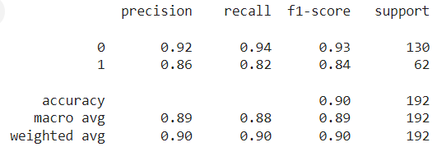

Fig 4.

3. Support Vector Classifier: -

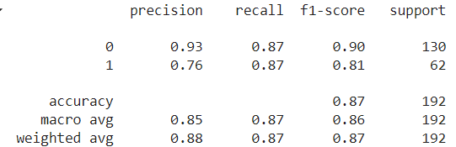

Fig 5.

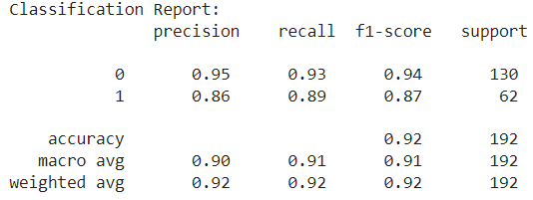 4. Random Forest Classifier: -

Fig 6.

5. Neural Network Classifier: -

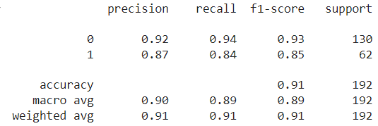

Fig 7.

**4.4 Result Analysis and Validation:**

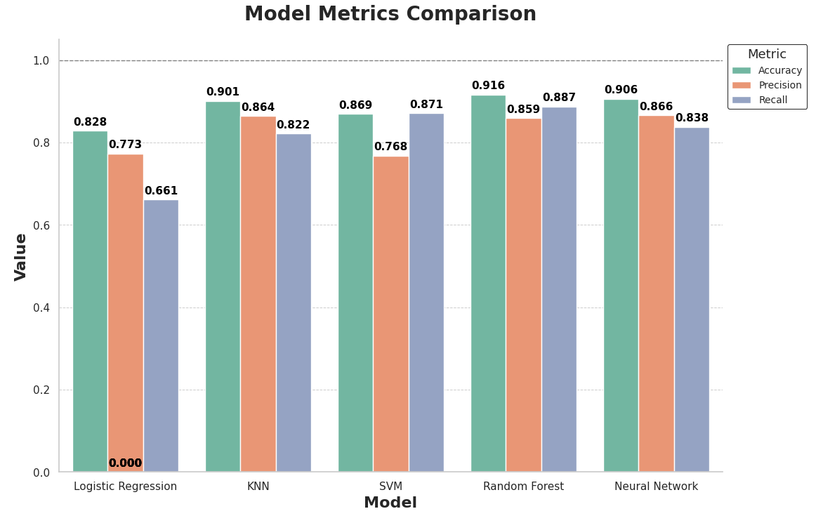Below two bar graphs give the brief details regarding the result analysis and Validation.

Fig 8. Model Metrics Comparison

The above "Model Metrics Comparison" chart provides an in-depth evaluation of five machine learning models: Logistic Regression, K-Nearest Neighbors (KNN), Support Vector Machine (SVM), Random Forest, and Neural Network. The models are assessed using three essential metrics: Accuracy, Precision, and Recall.

Logistic Regression shows an Accuracy of 0.828, a Precision of 0.773, but a notably low Recall of 0.661, indicating it failed to correctly identify relevant instances. KNN, however, stands out with an Accuracy of 0.901, Precision of 0.864, and Recall of 0.822, demonstrating a well-balanced performance across all metrics.

The SVM model presents an Accuracy of 0.869, with Precision and Recall scores of 0.871 and 0.768, respectively, reflecting its effectiveness but slightly lower recall compared to precision.

Random Forest excels with the highest Accuracy of 0.916, coupled with a Precision of 0.859 and Recall of 0.887, indicating its strong predictive power and ability to correctly identify relevant instances. The Neural Network follows closely, showcasing an Accuracy of 0.906, Precision of 0.866, and Recall of 0.838, making it a robust contender.

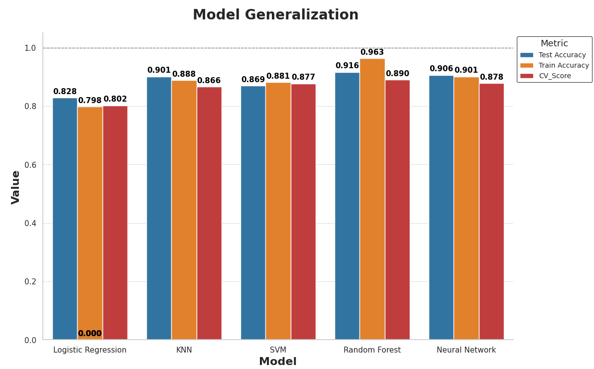Overall, Random Forest and KNN emerge as the top performers, with Random Forest having a slight edge due to its superior recall. The Neural Network also demonstrates strong capabilities, whereas Logistic Regression's unusually low recall suggests a need for further model tuning or a review of data processing. This comparison underscores the importance of evaluating multiple metrics to gain a comprehensive understanding of model performance.

Fig 9. Model Generalization

The chart titled above "Model Generalization" provides a comparative analysis of five different machine learning models: Logistic Regression, K-Nearest Neighbors (KNN), Support Vector Machine (SVM), Random Forest, and Neural Network. The comparison is based on three key metrics: Test Accuracy, Train Accuracy, and Cross-Validation Score (CV Score).

Logistic Regression exhibits a Test Accuracy of 0.828, Train Accuracy of 0.798, and a CV Score of 0.802. However, an anomaly is noted with a CV Score of 0.000, likely indicating a data or calculation error. KNN shows a high-test Accuracy of 0.901, with corresponding Train and CV Scores of 0.888 and 0.866, respectively, suggesting robust generalization. SVM presents balanced performance metrics with Test Accuracy at 0.869, Train Accuracy at 0.881, and CV Score at 0.877, reflecting consistent model behavior.

Random Forest outperforms other models with a remarkable Test Accuracy of 0.916, Train Accuracy of 0.963, and a CV Score of 0.890, indicating excellent generalization and minimal overfitting. The Neural Network follows closely with a Test Accuracy of 0.906, Train Accuracy of 0.901, and a CV Score of 0.878, demonstrating its effectiveness and stability.

Overall, the Random Forest model leads in terms of generalization capability, closely followed by the Neural Network, while KNN and SVM also show strong, reliable performance. Logistic Regression, despite generally good metrics, but couldn’t perform that well over the given dataset.

**5. CONCLUSIONS**

The project “Demystifying The Housing Market: Unveiling The Power Of Machine Learning In Price Forecasting” demonstrates the practical application of machine learning techniques to solve real-world problems in the domain of real estate. Through a comprehensive methodology that includes data collection, cleaning, feature engineering, model building, evaluation, and deployment, the project achieves its objective of accurately predicting house prices in Bangalore.

**Key Takeaways**

1. **Data-Driven Insights:** The project highlights the importance of data quality and preprocessing in building effective predictive models. By cleaning the data and engineering meaningful features, the model's performance significantly improved.

2. **Model Performance:** Among various machine learning algorithms tested, the linear regression model emerged as the most effective, achieving an R² score of over 80%. This indicates a strong correlation between the predicted and actual house prices, affirming the model's reliability.

3. **Model Evaluation and Validation:** The use of K-fold Cross-Validation and GridSearchCV ensured robust model evaluation and parameter tuning. This systematic approach to model validation helped in selecting the best-performing model with optimal parameters.

4. **Deployment and Usability:** The deployment of the predictive model as a web application on Netlify makes it accessible for users to input key features and obtain house price estimates. This practical implementation showcases the end-to-end process from data analysis to real-world application.

5. **Interdisciplinary Integration:** The project underscores the interdisciplinary nature of data science, combining aspects of statistical analysis, machine learning, software development, and domain-specific knowledge to deliver a comprehensive solution.

**Future Work**

While the project has successfully built a robust house price prediction model, there are several avenues for future enhancement:

* **Incorporating More Features:** Additional features such as proximity to amenities, historical price trends, and economic indicators could further improve the model's accuracy.
* **Advanced Algorithms:** Exploring advanced algorithms like ensemble methods, neural networks, or gradient boosting could provide even better predictions.
* **Dynamic Data Updates:** Implementing a system for dynamic data updates would ensure that the model remains accurate over time with the latest real estate market trends.
* **User Experience:** Enhancing the web application's user interface and providing more detailed insights and visualizations could improve user engagement and experience.

**Final Thoughts**

The project exemplifies the power of machine learning in transforming data into actionable insights. By accurately predicting house prices, the project provides valuable assistance to homebuyers, real estate agents, and investors in making informed decisions. This project serves as a testament to the potential of data science to address complex challenges and drive innovation in various industries.

**6. REFERENCES**

1. MOUSA, A., MUSTAFA, W., MARQAS, R.B. and MOHAMMED, S.H., 2023. A comparative study of diabetes detection using the Pima Indian diabetes database. *Journal of Duhok University*, *26*(2), pp.277-288.
2. Sharma, C. and Sharma, S., 2024, January. Data-Driven Approaches to Early Diabetes Prediction: A Comprehensive Exploration of Predictive Analytics and Machine Learning. In *2024 ASU International Conference in Emerging Technologies for Sustainability and Intelligent Systems (ICETSIS)* (pp. 872-876). IEEE.
3. Khanam, J.J. and Foo, S.Y., 2021. A comparison of machine learning algorithms for diabetes prediction. Ict Express, 7(4), pp.432-439.
4. Chang, V., Bailey, J., Xu, Q.A. and Sun, Z., 2023. Pima Indians diabetes mellitus classification based on machine learning (ML) algorithms. Neural Computing and Applications, 35(22), pp.16157-16173.
5. Hastie, T., Tibshirani, R., & Friedman, J. "The Elements of Statistical Learning: Data Mining, Inference, and Prediction." Springer, 2009.
6. National Institute of Diabetes and Digestive and Kidney Diseases. "Pima Indians Diabetes Database." Available at: https:/[/www.ka](http://www.kaggle.com/uciml/pima-indians-diabetes-database)g[gle.com/uciml/pima-indians-diabetes-database.](http://www.kaggle.com/uciml/pima-indians-diabetes-database)
7. **APPENDICES**

In the "Demystifying The Housing Market: Unveiling The Power Of Machine Learning In Price Forecasting" project, a comprehensive methodology was employed using a dataset sourced from real estate records in Bangalore. Thorough data preprocessing was conducted, including cleaning, imputation, normalization using Standard Scaler, and one-hot encoding for categorical features. Key features included area type, availability, location, size, society, total_sqft, bath, balcony, and price. We trained and evaluated six machine learning models: Linear Regression, Lasso Regression, Decision Tree, Random Forest, XGBoost, and Gradient Boosting. Linear Regression emerged as the top performer with an accuracy of 0.847951, followed by XGBoost and Random Forest with accuracy of 0.820081 and 0.794833, respectively. Performance metrics such as Mean Squared Error (MSE) and Root Mean Squared Error (RMSE) were used to assess model accuracy. Hyperparameter tuning through GridSearchCV and cross-validation ensured model robustness. Development tools included Python programming with libraries such as Scikit-learn, Pandas, NumPy, Matplotlib, and Seaborn, within environments like Anaconda, Jupyter Notebook, and Visual Studio Code. Data visualizations were created using Matplotlib and Seaborn, aiding in result interpretation. The hardware setup featured an Intel i5 11th generation processor, 8GB DDR4 RAM, and a combination of SSD and HDD storage. This project highlighted the potential of machine learning in the real estate sector, providing accurate price predictions that can inform and stabilize the housing market, enhancing decision-making for buyers, sellers, and investors, and contributing to a more transparent and efficient real estate market in Bangalore.

1. **REFLECTION OF THE TEAM MEMBERS ON THE PROJECT**

When working together on a project, each team member's contributions are crucial. Teamwork boosts performance and efficiency, leading to a comprehensive understanding of all project aspects. When issues come up, the team collaborates to propose solutions, and the best idea is chosen, resulting in improved outcomes. Here are the contributions of our team members:

**Swayam Prakash Sahu:** Working on this project has been a rewarding experience. My focus on model implementation, result analysis, and design taught me the intricacies of machine learning in real estate price prediction. Seeing the Linear Regression model achieve high accuracy was particularly satisfying. I also took charge of crafting a detailed and insightful report, as well as creating a compelling PowerPoint presentation. This project has deepened my appreciation for the potential of technology in improving prediction and decision-making in the real estate.   
  
**Ansuman Patro:** Participating in this project has been a valuable learning experience. Working on the problem statement, documentation, and literature survey helped me understand the critical aspects of project management. It was fulfilling to see our efforts culminate in a comprehensive and impactful report. This project has enhanced my skills in identifying key issues and effectively communicating our findings.  
  
**Anuj Pratap Singh:** My contribution to this project included building the frontend user interface which will interact with the model and give users the appropriate price of the home, which laid a strong foundation for our work. These efforts were instrumental in effectively communicating our project's findings and achievements.   
  
**Swayam Samantaray:** My primary contributions involved configuring the system setup, defining crucial parameters, and meticulously cleaning the data. These tasks were pivotal in ensuring the accuracy and reliability of our project outcomes. My efforts streamlined processes and facilitated a solid foundation for data analysis and interpretation, ultimately contributing to the project's overall success.